**Lab 3 – Flexbox**

## Getting ready.

1. Extract zip file content (Lab Three folder) into your local se-nz-pt-a-4jul22 repository > your own folder.
2. Commit your new files with the message “Lab Three setup complete”.
3. Make sure you have installed “Live Server” extension on your VS Code.
4. If you are having any difficulties, contact your trainers by sending slack message or zoom chat.

The goal of this lab is to help you familiarize with flexbox. In this lab we’ll be using functional CSS which in a nutshell is very easy, e.g. m-20 class will correspond to margin with value 20 units and mt will correspond to margin-top with value 20 units.

1. Familiarize with provided classes and HTML

2. Basic flexbox

2.1 Fill in .flex-container class and add `display: flex;` to it

2.2 Fill in flex-item-1,2,3,4 classes and set `flex: <number>` on them

2.3 How does the value for the flex affect the size of the item? (Write your answer here)

Final result



3. Flex center

3.1 Edit flex-center content and set values for justify-content and align-items

3.2 Try out different values for both CSS rules. Your final goal is to center item within its container both horizontally and vertically

Final result

4. Spacing elements on the opposites sites

4.1 Edit flex-space-between class and set appropriate justify-content to space elements on the opposite sites

Final result



5. Wrapping items

5.1 fill in the rule for flex-basis-50 and flex-wrap so the container has `flex-wrap: wrap;` and flex items have flex-basis set to 50%

Final result

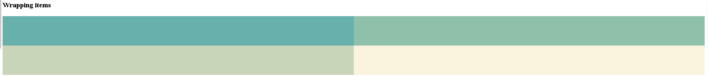

6. Try changing flex-direction or using different values for flexbox containers and items. Use the reference below to find some of the commonly used values.

**Links:**

https://css-tricks.com/snippets/css/a-guide-to-flexbox/

**Reference:**

Look at those collected CSS values for flexbox here and try out various combinations of parameters:

flexbox container:

display: flex | inline-flex;

flex-direction: row | row-reverse | column | column-reverse;

flex-wrap: nowrap | wrap | wrap-reverse;

justify-content: flex-start | flex-end | center | space-between | space-around | space-evenly;

align-items: stretch | flex-start | flex-end | center | baseline;

align-content: flex-start | flex-end | center | space-between | space-around | space-evenly | stretch;

flex-flow: <'flex-direction'> <'flex-wrap'>; // shorthand property

flexbox items:

flex-grow: <number>;

flex-shrink: <number>;

flex-basis: auto | <width>;

order: <number>;

align-self: auto | flex-start | flex-end | center | baseline | stretch;

flex: none | [ <'flex-grow'> <'flex-shrink'>? || <'flex-basis'> ]; // shorthand property

## Push to git.

1. Commit your work with message “Lab three completed”.
2. Push your work to se-nz-pt-a-4jul22. (don’t forget to pull first)